## RESULT ENTRY

|  |  |
| --- | --- |
| User Name: ……………………………………………. | Trainer Name: Ruchira Ariyasinghe |
| User Sign. : ……………………………………………. | Trainer Sign. : ……………………………………………. |

### Routine Tests – Result Entry

1. The patient’s results for the tests selected during registration will be entered using this module.
2. Select the patient whose result entry has to be done and click on ‘**Result** ‘ button or double click the patient whose result entry has to be done. All the visit details along with test selected will be displayed in the right hand side grid. Select the ‘Test’ from the test drop down whose results have to be entered. Click on select button.
3. The parameters for the selected test will be displayed in the grid below and the status (Pending\Complete) of the test will be displayed in the status box.
4. Against each parameter in the value column the user can enter results.

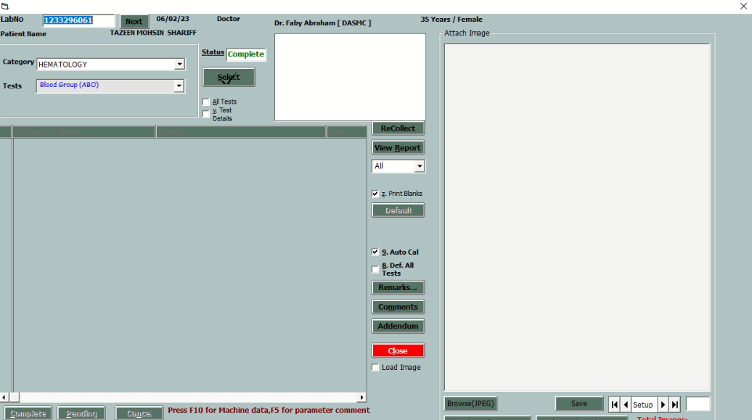

1. The help value if any for a parameter will be displayed on the left hand bottom corner.
2. Double click on the help value to select it in the grid. If any new Help Value has to be added, type the value in the result column, and press Ctrl, the value will be added to the previous help value list.
3. After the results are entered the user can click on ‘Mark Complete’ or ‘Mark Pending’ buttons depending on whether the result entry is completed or pending.
4. On clicking ‘Pending’ button, the user will be asked to enter a comment. This is to mention reason for marking test as pending for other users to view. Also, the status of the test will change to ‘Pending’

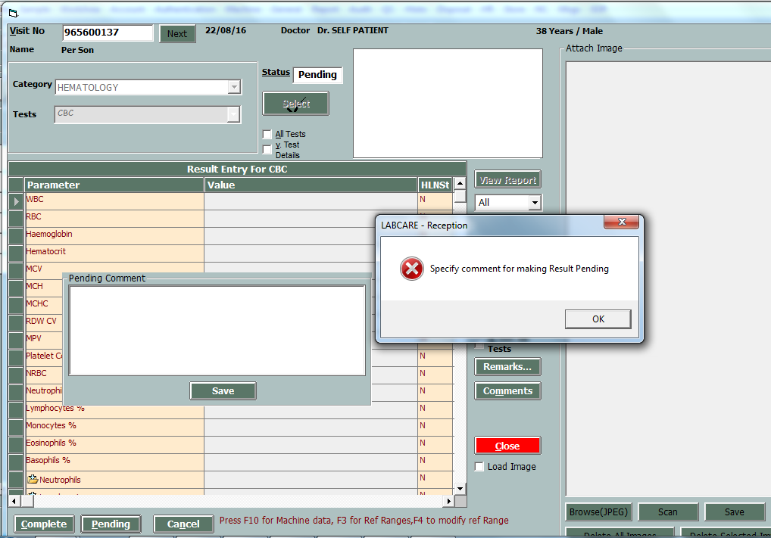

1. If some wrong entry is done the user can click on ‘Cancel’ button to cancel the entry.
2. Click on default button to enter default values for the parameters.
3. Click on ‘Test Comment’ button to enter comments if any for the selected test.
4. Click on ‘Remarks’ button to enter remarks if any.
5. After the results are marked as complete, the user can click on reports button to print the report. Select the report style from the drop down below the report button; by default ‘ALL’ is selected. If the ‘Printer’ box is checked then report will be sent directly to the printer else the report will be shown on the window.
6. Once the report is displayed on the Screen or sent to printer for printing, A box appears confirming for marking the test printed for the current Format. If ‘Yes’ is selected, the patient status will be marked as ‘Printed’ and if ‘No’ is selected, the patient status will remain ‘Completed’ for the tests but report will be shown authenticated. If the status is printed, the user wont be able to take a reprint from this option and if the status is Completed, then the user can take a print out again.
7. Press F5 to add remark for parameter. 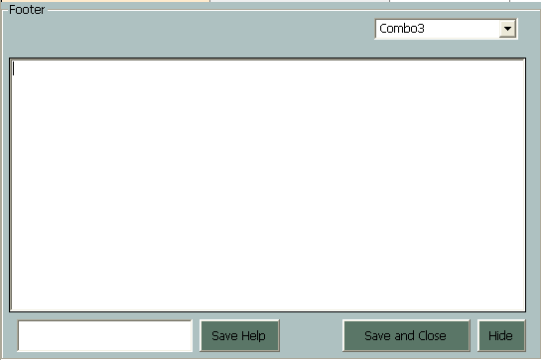

* Click on Save Help to add new save help values.
* Enter the remark and click on Save and Close button
* Click on Hide button to hide the window

1. Press F10 to view QC results.

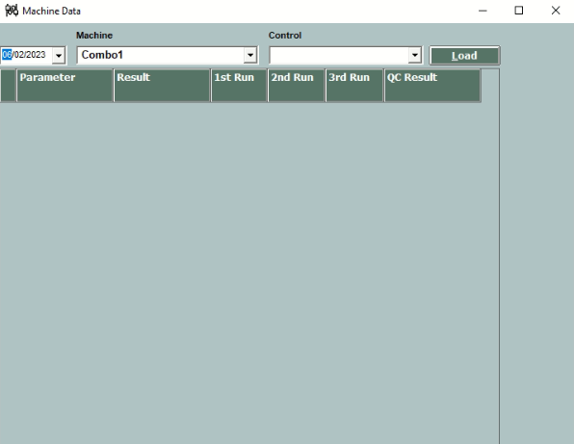

User can view QC result by pressing F5 key.

1. Press F4 to view Normal range and change the Normal range.
2. Timeline

   Description automatically generated with medium confidence

* BY pressing F4 key user can view reference range.
* Click on “Save For Patient Only” button to modify ref range for patient
* Click on “Save In master and for patient” to modify ref range in master and patient both.

### Memo Tests – Result Entry

1. .Memo tests reports are selected mostly for RADIOLOGY Tests.
2. .For memo tests, when the user clicks on ‘Select’ button, the provision to enter descriptive result for the test will be displayed.
3. .The user can select the font name, font size and other basic text editing options.
4. .Click on ‘Save Help’ button to save the current entered descriptive result for the current test as Help Value. The current entered descriptive value once saved as Help Value will be available for further patients.
5. .After entering the descriptive result for the selected test, the user can click on ‘Mark Complete’ to update status as complete or click on ‘Mark Pending’ to update the status as Pending.
6. .Click on ‘Cancel’ button to cancel the entered descriptive result and close the screen. The short cut keys are displayed for the user below the descriptive result entry box.
7. .Click on ‘Update’ button to save the descriptive result entered. Click on ‘Help Value’ button to get the help value of the selected test.
8. .While selecting a Help Value, by default, the View option is checked. If the user wants to select only a particular page from the Help Value, the View option has to be unchecked, & the Enter key is pressed, a window will open up & the user will be able to select a particular page from the list.

##### Result Entry – Test Wise

1. The results for the selected tests during registration will be entered using this module.
2. The parameters for the selected test & selected Patient will be displayed in the grid below and the status (Pending\Complete) of the test will be displayed in the status box.
3. Against each parameter in the value column the user can enter results.
4. The help value if any for a parameter will be displayed on the left hand bottom corner. Double click on the help value to select it in the grid. If any new Help Value has to be added, type the value in the result column, and press F3, the value will be available next time when you are entering for that particular parameter.
5. After the results are entered the user can click on ‘Mark Complete’ or ‘Mark Pending’ buttons depending on whether the result entry is completed or pending.
6. If some wrong entry is done the user can click on ‘Cancel’ button to cancel the entry.
7. Click on default button to enter default values for the parameters.
8. Click on ‘Test Comment’ button to enter comments if any for the selected test.
9. Click on ‘Remarks’ button to enter remarks if any.
10. After the results are marked as complete, the user can click on reports button to print the report. Select the report style from the drop down below the report button; by default ‘ALL’ is selected. If the ‘Printer’ box is checked then the report will be sent directly to the printer else the report will be shown in the window.
11. Once the reports are displayed on the Screen or send to printer for printing, a box appears confirming for marking the test printed for the current Format. If ‘Yes’ is selected, the patient status will be marked as ‘Printed’ and if ‘No’ is selected, the patient status will remain ‘Completed’ for that tests. If the status is printed, the user wont be able to take a Reprint from this option or if the status is Completed, then the user can take a print out again.